First Grade Understanding Place Value Parent Letter

Dear First Grade Family,

During the week of <date> we will be starting a new math unit focused on understanding place value. The purpose of this letter is to give you some background information about our new unit.

Focus of the Unit
Your first grader is learning to think of two-digit numbers as being made of tens and ones. Students will use this understanding to compare the values of these numbers between 10 and 100. They will practice comparing two numbers (e.g., 42 is more than 31. 23 is less than 52, 61 is the same amount as 61) and then learn to connect those words to the symbols that mean less than (<), greater than (>), and equal to (=). An important part of this unit is for students to explain their comparisons. This understanding of place value is foundational as students build fluency with addition and subtraction.

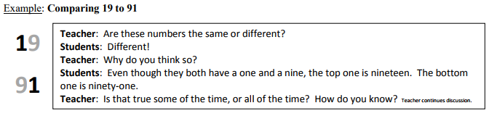
19 < 91

Building Off Past Mathematics
Last year students learned to compare numbers up to 10 using words to tell which was less than, equal to, or greater than. However, they did not use symbols in their comparisons. Students explored early place value concepts as they learned about teen numbers being made of “ten and some more.”

Earlier this year, students worked with counting patterns as they practiced reading, writing, and representing numbers within 100. They learned that a numeral can stand for different amounts depending on its position in the number. These ideas will be extended through this unit.

.
Strategies that Students Will Learn

Students will learn to justify their number comparisons based on what they know about counting. They may use tools such as the 100 chart or a number line as supports.

Students will learn to model groups of tens and ones in two-digit numbers with materials and drawings to justify their number comparisons. They may use a work mat labeled “tens” and “ones” as a support.

Students will learn to use precise language to explain their comparisons. This will include words such as tens, ones, bundle, left-overs, singles, groups, greater/less than, equal to, and compare.

Ideas for Home Support

Say a two-digit number and have your child to write the number (such as 42). Challenge them to use objects or a drawing to represent that number. Ask them to show you where the 4 is in their representation (the 4 tens) and where the 2 is (the 2 ones). Repeat with other numbers.

Challenge students to count a large group of objects (up to 100) by grouping them into tens and ones to find the total. Some ideas for objects could be pennies in piles, straws grouped with rubber bands, or beans or bottle caps in small cups. You may ask: How many do you have altogether? What’s the digit in the tens place? Show me. How many ones are in that number? Show me. You could split the objects into two groups and then ask students to compare to find out which group is <, =, or >. It’s important that they use the vocabulary when they explain less than, equal to, or greater than, as they learn the meanings of the symbols.

Create 2 two-digit numbers with your child. This may be done by rolling dice, flipping playing cards, or just naming digits from 0-9. Have students write the numbers leaving a little space in between. Have them tell you the comparison out loud and then write the comparison with the correct symbol between the numbers (For the numbers 46 and 28, students would say 46 is greater than 28 and write > between the numbers). Make sure to let them explain how they know. Encourage precise explanations such as: 46 has 4 tens and 28 only has 2 tens or When I count, I get to 28 before I get to 46 because 28 is a smaller number.

Reading books is a great way to enhance learning! You may check out the following titles at your local library or you may find free online versions to support the learning in this unit.
- Albert Keeps Score by Daphne Skinner
- Counting Cockatoos by Stella Blackstone.
- Just Enough Carrots by Stuart J. Murphy
- More or Less by Stuart J. Murphy

Thank you for serving as partners in your child’s success as a mathematician!

<signature>

