First Grade Money Letter

Dear First Grade Family,

During the week of <date> we will be starting a new math unit focused on identifying coins (quarters, dimes, nickels and pennies) and relating their value to pennies. The purpose of this letter is to give you some background information about our new unit.

Focus of the Unit
Your first grader will focus on building a basic understanding of money. Students will compare how coins are alike and different to help them identify and learn the names of each coin (penny, nickel, dime, and quarter). They will also learn the coin values, which is the number of pennies that each coin represents. As students start to understand the values of each coin, they will count sets of the same coins. They will count the value of like coins by skip counting.

Coins and their value  Quarter  25 cents  Nickel  5 cents  Dime  10 cents  Penny  1 cent  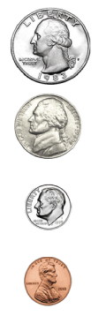 | 25 pennies = 25 cents  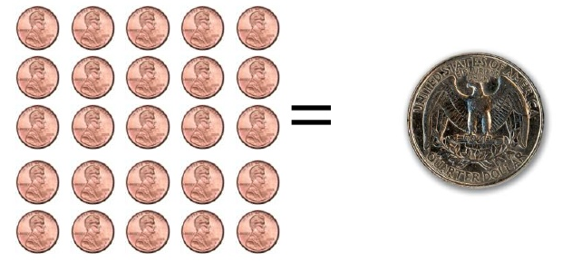  1 dime = 10 pennies  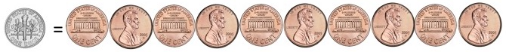  5 pennies = 1 nickel  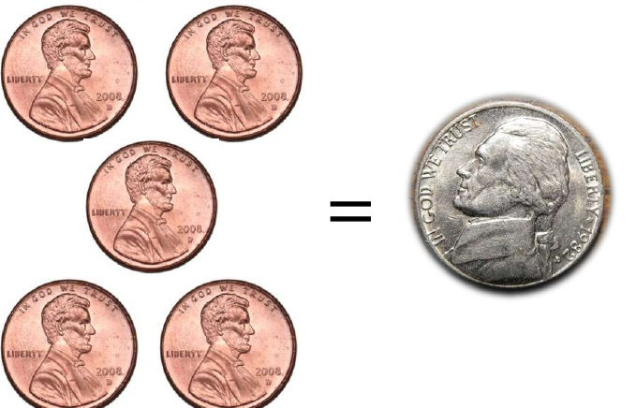

Building Off Past Mathematics

Last year your child learned to count by ones and tens in kindergarten, so counting to find the value of a set of pennies or dimes will be connected to their counting skills. When students counted by tens, they were expected to master counting only on the decade numbers (0, 10, 20, 30, etc.) and understand that the next number in the sequence is “ten more” or one more group of ten. They also learned to use a tens frame to organize and represent sets of tens. This will help them to count groups of dimes, and it will help them understand how to skip count by fives when they learn to count nickels.

Strategies that Students Will Learn

Students will learn to identify which coin is a penny, nickel, dime or quarter by looking at how the coins are alike and different. Your child will learn to sort coins based on what they notice and explain how they sorted the coins.

They will practice with counting by fives as they count nickels. They will touch five frames to represent nickels as they count or visualize the process. As students practice counting by fives, they will increase their ability to count nickels.

They will explore the value of the nickel, dime, and quarter. They will be able to tell how many cents are represented by each coin and count sets of each coin (pennies, nickels, dimes, and quarters) to identify how much money is in each set.

Students group objects by ones, fives, tens and twenty-fives on number frames to show the value of each coin. Then they will use counting patterns to count sets of like coins. They will explore different ways to use sets of like coins to create the same value.

Ideas for Home Support

Give your child a variety of coins and let them sort the coins based on what they notice. Ask them to explain how they sorted the coins. After they tell the value of each coin, they may count sets of like coins by counting by 1’s, 5’s, 10’s and 25’s.

Play the “Comparing Coins” game. Show your child a coin and ask, “How many cents is this coin worth?” Then have your child to show the value of that coin using pennies. For example, a quarter has the same value of 25 pennies. Repeat for all coins. Sometimes show the “heads” side and other times show the “tails” side.

Reading books is a great way to enhance learning! You may check out the following titles at your local library or you may find free online versions to support the learning in this unit.
- Benny’s Pennies by Pat Brisson
- Berenstain Bears Trouble with Money by Stan and Jan Berenstain
- Bunny Money by Rosemary Wells
- A Chair for My Mother by Vera B. Williams
- Jelly Beans for Sale by Bruce McMillan
- Monster Money by Grace Maccarone
- 26 Letters and 99 Cents by Tana Hoban

Thank you for serving as partners in your child’s success as a mathematician!

<signature>

