First Grade Telling Time Parent Letter

Dear First Grade Family,

During the week of <date> we will be starting a new math unit focused on telling and writing time to the hour and half-hour. The purpose of this letter is to give you some background information about our new unit.

Focus of the Unit

Your first grader will focus on telling and writing time in hours and half-hours using analog and digital clocks throughout this unit. It is important for students to understand the differences between the two hands on the analog clock and the functions of these hands. Our goal is for students to read both analog and digital clocks and tell and write the time to the hour and half-hour.

Analog Clocks Digital Clocks
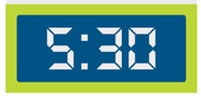
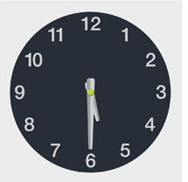

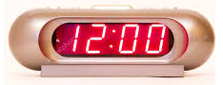
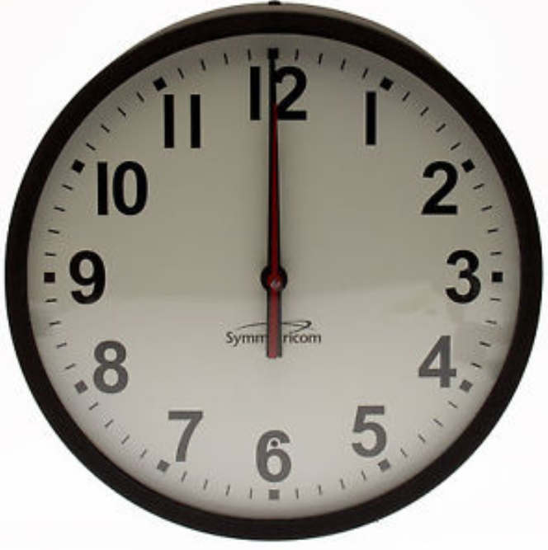

Building Off Past Mathematics

Last year your child learned how to write numbers 0-20 and use the numbers to represent a collection of objects. In this unit, your child will be able to read and write the numerals that represent the hours and half hours on an analog or a digital clock. When telling time on a digital clock, your child will recognize the numbers that name the hour and minutes since they learned to read and recognize numbers up to one hundred in kindergarten.

They will also be able to use correct counting skills and one-to-one pointing that they learned last year as they touch each mark that shows minutes on the face of the clock. This will help as they learn to set clock hands to show 30 minutes past the hour and as they demonstrate that 60 minutes are in an hour.

Strategies that Students Will Learn

Students will become familiar with the clock face by exploring the meanings of the hour and minute hands. Students will be making a clock face and relating the numbers to a circular number line.

Your child will first use the hour hand on an analog clock to tell if the time is on the hour or before or after given hours. Students will learn when the hour hand points directly to a number one on the face of an analog clock and the minute hand points directly on the 12 then the time is on the hour and read as o’clock. This one-handed clock model helps students see that on the half hour, the hour hand is halfway between the hours.

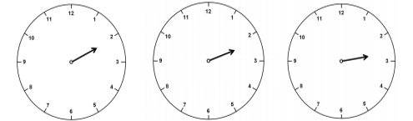
All of these clocks indicate the hour of “two”, although they look slightly different.
This is an important idea for students as they learn to tell time.

Students will use student-made clocks and/or small clock models to practice setting clock hands in the right positions for different hours and half hours.

Students will have many opportunities to practice reading a digital time and then representing the time on an analog clock. They will also read the time at an analog clock and then write the time as it would be shown on a digital clock. This practice will expand students’ understanding of telling time to the hour and half hour.

Ideas for Home Support

Use language such as “about 5 o’clock” and “a little bit past 6 o’clock” and “almost 8 o’clock” to help your child begin to read a clock with some accuracy.

Your child may use a paper plate to create the face of an analog clock by filling in the numbers in the correct areas on the paper plate. Challenge students to read a time on a digital clock and then show where the hour hand and minute hand would be on their homemade analog clocks.

Talk about times your child can display on the homemade paper clock. You can spark conversations about time with the following statements:

- I looked at the clock and the hour hand was halfway between 4 and 5. About what time is it? Explain your thinking.
- Explain how you know when it is 1:00 by viewing the face of a clock.
- I made the time 6:30 on the face of a clock by pointing both hands exactly at the 6. Am I correct? Explain your thinking.

Play a “Simon Says” game to practice time. Students can represent a given time that “Simon Says” on their on the analog paper plate clock.

Using a one-handed clock, parents place the hour hand at a position on the face of the clock and let the child predict where the minute hand could be on the clock.

Reading books is a great way to enhance learning! You may check out the following titles at your local library or you may find free online versions to support the learning in this unit.
- All in a Day by Mitumasa Anno
- Around the Clock with Harriet by Betsy and Giulio Maestro
- Bats Around the Clock by Kathi Appelt
- Game Time! by Stuart J. Murphy
- The Grouchy Ladybug by Eric Carle
- It’s About Time, Max! by Kitty Richards

Thank you for serving as partners in your child’s success as a mathematician!

<signature>

