First Grade Measurement Parent Letter

Dear First Grade Family,

During the week of <date> we will be starting a new math unit focused on measurement. The purpose of this letter is to give you some background information about our new unit.

Focus of the Unit

Students measure with nonstandard units (cubes, paperclips, etc.), order objects by length, and compare the lengths of objects. The use of inch tiles and centimeter cubes introduces the idea of standard measurement. Students connect numbers to length. The idea is introduced that the size of a unit used when measuring an object affects the number used of that unit.

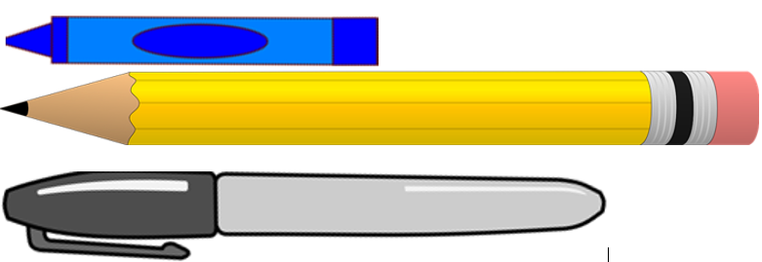 | - Order three objects by length.  - Reason that if the marker is shorter than the pencil, and the crayon is shorter than the marker, the crayon is also shorter than the pencil.

Building off Past Mathematics

In kindergarten, students first learn which attributes are measurable (height, weight, etc.) and work on building their vocabulary to describe those measurable attributes. The expectation is students describe an object in more than one way Ex: This block is long and heavy. Kindergarteners also directly compare two objects. Ex: The red book is heavier than the blue book. I am taller than my friend.

Strategies That Students Will Learn

Meeting the Standard | Incomplete Understanding
Measuring  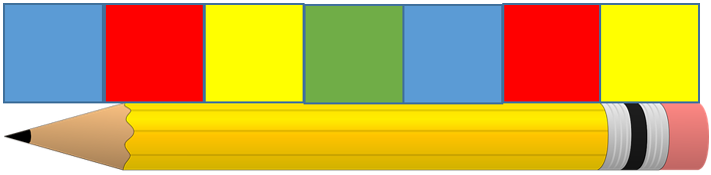  Measure an object from end to end with no gaps or overlaps using nonstandard units. Recognize the pencil’s length is 7 tiles. | Measuring  Measuring with gaps.  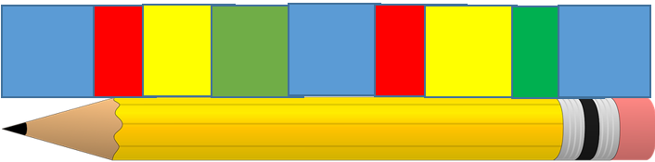  Measuring with overlaps

Meeting the Standard | Incomplete Understanding
Comparing  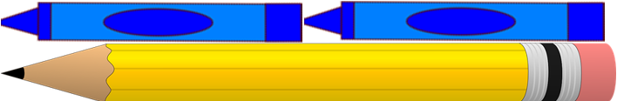  Both pencils are the same length. Measurements change when the size of the unit changes. It takes more tiles than crayons to measure the pencil because the tiles are smaller. It takes more of a smaller unit to cover the same distance. | Comparing  The top pencil is longer because it is 7 tiles long and the bottom pencil is shorter because it is only 2 crayons long. 7 is more than two, so the top pencil is longer.

Ideas for Home Support
- Measure household items using nonstandard items (cereal, paperclips, crayons, pretzel rods, etc.)
- Encourage your child to use measurement vocabulary
- Compare the lengths of objects directly by measuring and by using reasoning.

Vocabulary
end to end | height | length | long | longer | longest | measure
short | shorter | shortest | tall | taller | tallest | width

Thank you for serving as partners in your child’s success as a mathematician!

<signature>

