First Grade: Using Numbers to Explore Our Mathematical Community

Dear First Grade Family,

During the week of <date> we will be starting a new math unit focused on using numbers to build a mathematical community. The purpose of this letter is to give you some background information about our new unit.

Focus of the Unit

Your first grader will learn that math is all around us. It involves meaningful talk about strategies and students explaining their thinking. Teachers will establish expectations for math talk and help students create a “math mindset,” a belief that they can do math. They will learn to take risks when problem-solving and learn to persevere even when the problems they encounter are new to them. Students will learn that a math community values mistakes and struggles as learning opportunities. Activities in this unit of study will build a foundation for the entire year.

Building Off Past Mathematics

Last year your child counted numbers to 100 and learned to read and write numbers through 20. Students also began to think about the teen numbers as ten and some more through counting, grouping, and modeling. These concepts will be solidified and used as a starting point for instruction this year.

Strategies that Students Will Learn

Students will explore a variety of math concepts informally that will be studied again later in the year. Students will realize that numbers are important in the class and in their world. They will develop number sense as they count and compare quantities, describe situations mathematically, and describe objects.

Students will get to know each other by posing questions and collecting data about themselves and from their worlds (how we get to school, lunch choice, favorites). They will analyze the information collected and describe their findings in terms of numbers in each category and how many more or less in one category than another.

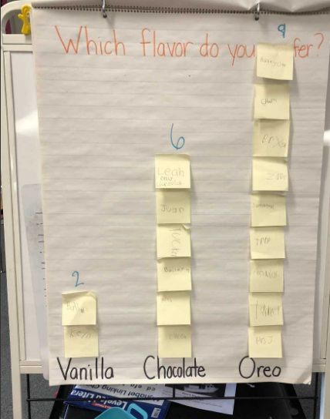

Students will learn to make groups of ten as an efficient way to count larger sets of objects. Counting by tens from any number will help them notice patterns that will later be important for adding and subtracting. Many models such as ten frames, ten sticks of cubes, and groups of ten objects bundled together will be used to represent numbers. These models will help students learn to compose and decompose one ten back into ten ones.

Ideas for Home Support

Encourage students’ natural curiosity about numbers in their world. Discuss topics that interest them in terms of numbers to help them build number sense. Just a few ideas are keeping score in games, drawing and describing shapes, or using language to compare items as taller, shorter, heavier, lighter, etc. than others. Some other general suggestions are:

- Read books about numbers
- Count sets of objects or money
- Sing number songs
- Play with blocks, puzzles, and shapes
- Talk positively about math

Thank you for serving as partners in your child’s success as a mathematician!

<signature>

