First Grade Partitioning Parent Letter

Dear First Grade Family,

During the week of <date> we will be starting a new math unit focused on partitioning. The purpose of this letter is to give you some background information about our new unit.

Focus of the Unit

First graders begin to learn about fractional pieces in this unit. They learn that they can split shapes into halves and fourths in different ways. They learn that they can put together halves or fourths to make a whole shape, and they learn to compare halves and fourths of the same shape. Although students are not using fraction notation (numerator over denominator), they are using the language of halves, fourths, half of, and fourth of.

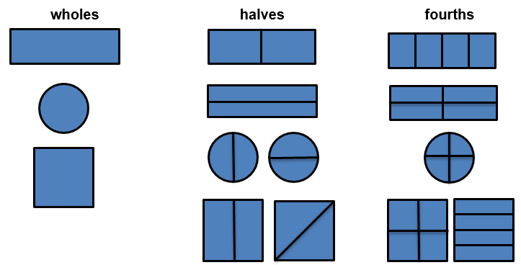

Building off Past Mathematics

First graders are building on their experiences of identifying and drawing shapes as well as creating a single new shape from a combination of shapes.
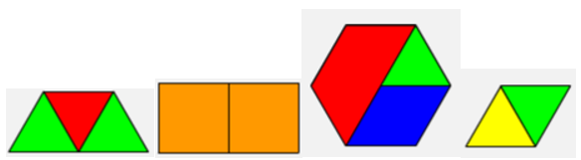

Strategies that Students Will Learn

Students will explore halves and fourths in a variety of ways which may include folding and cutting paper, using pattern blocks, using geoboards, and solving real-world problems involving sharing cookies, brownies, pizzas, sandwiches, etc.

Ideas for Home Support

There are many ways to support your child and make connections at home with partitioning.
- When you make a meal or a snack, provide opportunities for children to hear and use the vocabulary whole, halves, fourths, half of, and fourth of. You could ask questions such as:
  - Would you like your sandwich partitioned into halves or fourths?
  - How many halves are in one whole sandwich?
  - How many fourths are in one whole sandwich?
  - Which is bigger, the half or the fourth? Why?
  - If the sandwich is divided into two pieces, and the pieces are not equal, are they still halves? Why or why not?
  - Do equal shares need to be the same shape? Why or why not?
(Other food items could be crackers, fruit, pizza, snack cakes, etc.)

- The next time you get out play dough, encourage your child to use his or her imagination to create and partition shapes equally into halves and fourths. How many different ways can you partition a rectangle into four equal parts? What are all the things that rectangle could be? What about a circle? How could we partition it?

- Check out the public library for books involving halves and fourths such as:
  - Give Me Half! and Let’s Fly a Kite by Stuart J. Murphy
  - Eating Fractions by Bruce McMillan

Thank you for serving as partners in your child’s success as a mathematician!

<signature>

