Selecting Tools and Measuring Length Accurately

Dear ____________,

During the week of <date> we will be starting a new math unit focused on choosing the best tool for measuring length and measuring length accurately. The purpose of this letter is to give you some background information about our new unit.

Focus of the Unit
Our 2nd grade students have had a lot of experience getting to know the attribute of length and measuring length accurately. Beginning in Kindergarten, students described and compared objects as shorter, longer, or the same length. Last year, in 1st Grade, students used items such as blocks, tiles, and erasers to measure and compare objects. Most students will be beginning this unit with the idea that the total length of an object can be broken down into equal, smaller pieces. Knowing how many units long something is allows children to compare objects that they might not have measured themselves. Second Grade is the first time that students are asked to use “standard units” such as inches, feet, yards, centimeters, and meters. Over the next few years, your child will be using what he or she learns to measure and calculate the perimeter, area, and volume of a variety of shapes and objects.

Your child will learn to:  - Measure multiple objects at school and home with different units  - Choose and use tools such as rulers, tape measures, meter sticks, yardsticks, and measuring tape  - Know common units such as inches, centimeters, feet, yards, and meters  - Decide which unit to use when measuring an object | 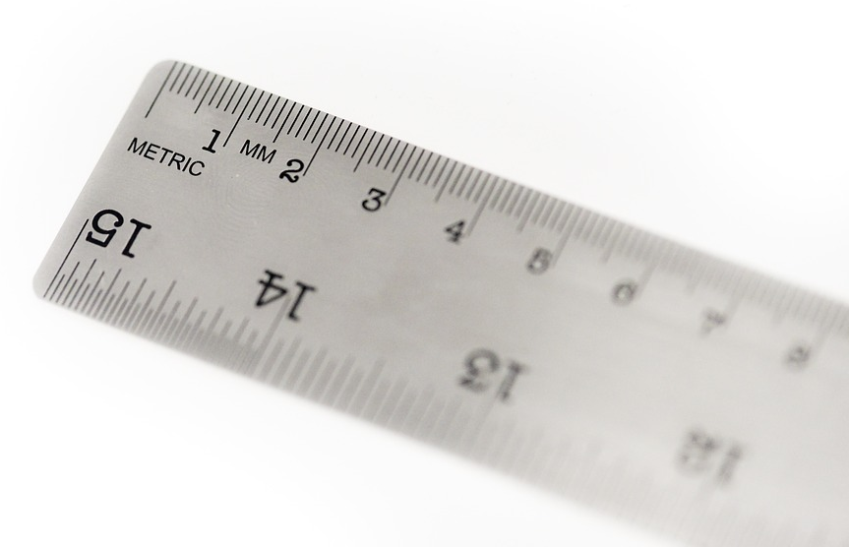

The Broken Ruler | Children who measure this nail accurately as 3 units show us that they understand how rulers and other tools measure length. If a child measures the nail as 6 units, she is relying purely on the label rather than considering the actual length of the nail.
Activities for Understanding Measurement at Home
The more children use and hear mathematical vocabulary, the better they understand and can explain their mathematical thinking.
There are many ways that you can help your child understand measurement at home.
- How can I help my child succeed with measurement? Create opportunities for your child to compare the lengths of books, toys, food, or anything else that you have. They can use tools such as rulers, yardsticks, or measuring tapes. Focus on how interesting it is to measure and describe their favorite things and enjoy the conversations you have.
- What if my child isn’t sure when to use a ruler, a meter stick, a tape measure, or a measuring tape? To help your child choose the right tool for the job, ask your questions such as: “How long do you think your sister’s foot is?”, “What tool could you use to find out?”, and “Why would you use that tool?” Practicing this thinking is fun for children and they will get comfortable with selecting and using measuring tools.
- What if my child uses a ruler or measuring tape, but doesn’t get the right length? Discuss precision with your child. Ask them questions like, “How do you know your measurement is accurate?” and “Is there another tool or unit that might help you measure _____ more accurately?” Help your child carefully line up their object with the 0 line on their measurement tool and make suggestions about how to use each tool. Learning to measure precisely takes dozens of opportunities to practice!

Measurement is learned through concrete, hands on activities, but we can practice skills we online. Check out these games and search for others.
- Practice measuring using centimeters and inches at ABCya.com. http://www.abcya.com/measuring.htm
- Practice measuring length with the PBS Kids game “Down the Tubes” http://pbskids.org/oddsquad/games/downthetubes/

Thank you for serving as partners in your child’s success as a mathematician!

<signature>

