Dear Family,
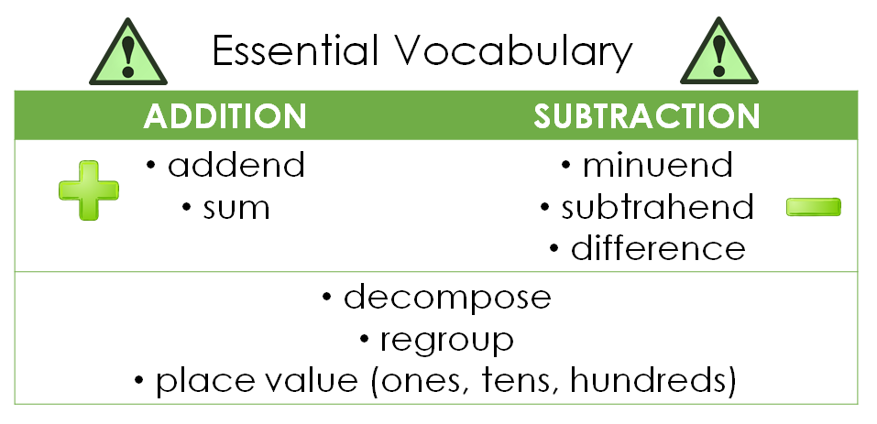
During this upcoming unit, we will be building on the mental math strategies that we have been using during our classroom number talks. Soon, you will notice that your child will begin using standard algorithms for addition and subtraction.

Let’s take a quick look at what students have learned so far:
Kindergarten | First Grade | Second Grade | Third Grade
Students learned the meaning of addition and subtraction.  They began solving simple word problems involving addition and subtraction within 10. | Students learned to add and subtract within 20 using strategies such as counting on, making ten, place value, and using a number line.  They also began to understand the equal sign as a point of balance in an equation. | Students learned to add and subtract within 100, finding the unknown number in an equation. They solved both one-step and two-step problems.  They also became fluent with addition and subtraction (within 20) using mental strategies. | Students solved two-step addition and subtraction problems using equations with a symbol for the unknown number.  They learned to use estimation strategies to assess the reasonableness of their answers to addition and subtraction problems up to 1,000.  They used place value and the relationship between addition and subtraction to solve problems.
Addition
So far this year, we have been strengthening our mental math skills. When students add mentally, they use place value understanding to solve problems efficiently. Once they have those skills in place, they are ready for the standard algorithm. Consider the progression below. Notice how the mental math strategies lead to a better understanding of the procedures associated with the standard addition algorithm.
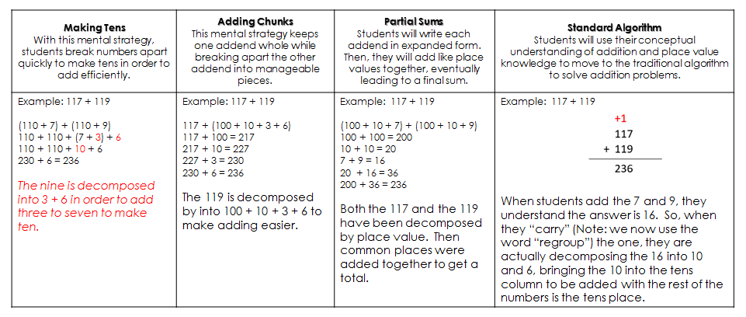

Subtraction
The mental math skills we are using have also been preparing our students to subtract using the standard algorithm. When students subtract mentally, they use place value to break apart numbers in order to reduce their totals. They also use the relationship between addition and subtraction to solve the problems. Once they have those skills in place, they are ready for the standard algorithm. Consider the progression below. Notice how the mental math strategies lead to a better understanding of the procedures associated with the standard subtraction algorithm.
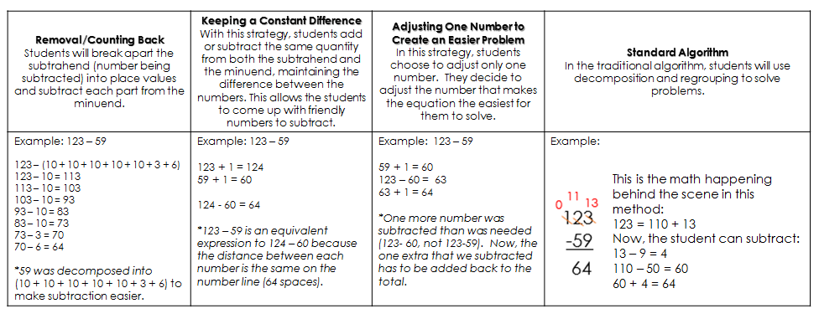

HOW CAN YOU HELP AT HOME?

- Keep an open mind! Your child is gaining a deep understanding of place value that will help them add and subtract in many situations, including places like the grocery store, where pencil and paper are not always handy.
- Encourage your child to talk to you about how they are solving problems. Often, they devise very creative ways to work out answers that are more efficient than the standard algorithm.
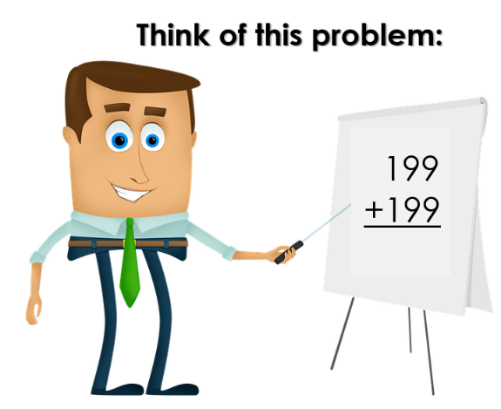
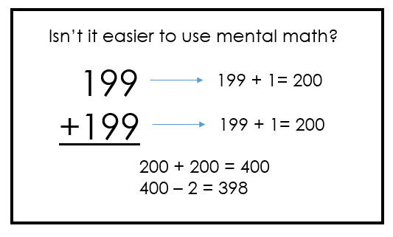
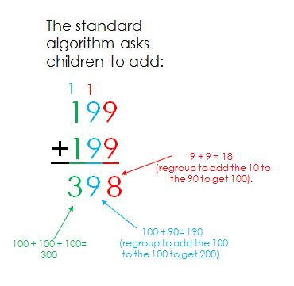
Thank you for serving as partners in your child’s success as a mathematician!

