Family Letter
2nd Grade Adding and Subtracting Strategies

Dear ____________

One of the math standards that we will be addressing this year is fluently adding and subtracting within 100 using strategies based on place value, properties of operations, and/or the relationship between addition and subtraction. In second grade, students will think beyond the process and application of procedures. This year students will think flexibly about numbers, see relationships between numbers, and deepen their understanding of place value. Students will continue to develop strong number sense which is crucial in mathematics..

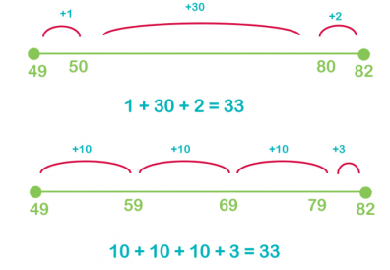
I respectfully ask that the standard algorithms for addition and subtraction not be taught at home. Teaching the algorithm too early can keep students from progressing in their number sense development. Second graders need time to build number sense, so these standard algorithms will not be introduced until fourth grade. Some of the strategies we will be using this year for addition and subtraction are shown below.

Number Line: The first number line shows how to solve 82 - 49 by counting up. This helps students to see the relationship between addition and subtraction, and the idea of a difference as a distance on the number line. The number line also allows students to be flexible in how they decompose numbers. Notice that on the second number line the problem (82-49) has been solved a different way, but both strategies show the correct answer.

Base Ten Blocks:
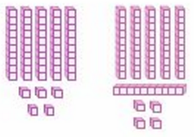
Base ten blocks are hands on manipulatives that help students understand place value. These manipulatives can be used to represent addition and subtraction. The blocks to the left show the problem 55 + 64. Students can easily count the tens, then count on the ones to determine the answer.

Decomposing Numbers: This strategy allows students to break down numbers so that they are easier to work with. For example, 55 + 64 cans be thought of as 50 + 5 and 64 could be thought of as 50 + 10 + 4. This strategy allows students to work with numbers that are “friendly” and manageable. The problem becomes 50 + 50 = 100; 100 + 10 = 110; 110 + 9 = 119.

These strategies I have shared with you are important because they build number sense and they are strategies that your student will be able to use as they progress through the grades and begin to perform operations with other types of numbers, specifically fractions and decimals.

I want to partner with you so that you feel comfortable with the math your child is learning. Math should be fun and enjoyable learning experience for your child. Below are links to resources that you may find helpful. I am attaching a game titled Road Rally. We have played this game in class so your student should be familiar with it. This is a fun game that you can play with your child that practices adding and subtracting within 20 and 100. It will help develop that number sense that is so important to mathematical success.

Thank you for serving as partners in your child’s success as a mathematician!

<signature>

