Grade 3: Cluster 2
Using Data to Solve Problems

Dear ____________

During the week of <date> we will be starting a new math unit focused on using data to solve problems. The purpose of this letter is to give you some background information about our new unit.

Focus of the Unit
This unit will focus on exploring data, which allows them to get to know more about their classmates and the world around them, in addition to building a foundation for the study of statistics and probability in later grades. This work includes solving problems that involve addition, subtraction, and multiplication, which allows students to strengthen and apply what they are learning in regard to computation.
Students will:
- Ask questions that involve up to four categories of data.
- Collect, represent and interpret data in frequency tables, picture graphs, or bar graphs.
- Use addition, subtraction, and multiplication to solve one-step “how many more” and “how many less” problems using information from these graphs.
- Use addition and subtraction to solve two-step “how many more” and “how many less” problems using information from these graphs.
- Share their thinking by communicating their reasoning and sharing their solutions.

Building off past mathematics
In grade 2 students worked with the process of data collection as they posed relevant questions, collected data to answer their questions, organized data, and interpreted the results. Then, students solved one and two step problems related to the collected data. They constructed simple picture and bar graphs with a single-unit scale. This unit builds on that work.

Strategies that students will learn
Students will work with the concept of scale that connects to the work they have done previously with equal groups. Students draw picture graphs in which each picture represents more than one object, and they draw bar graphs in which the height of the bar is multiplied by a scale factor to determine the number of objects in the category. This connects with the emphasis on multiplication in this grade and allows students to represent larger data sets on a graph. For example, using a scale factor of 10, as pictured in the graph below, allows students to collect and represent data involving larger numbers.
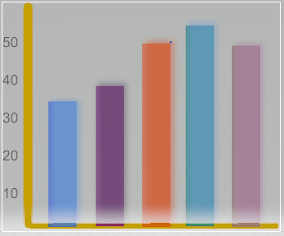

By the end of Grade 3, students will be able to draw a scaled picture graph or a scaled bar graph to represent a data set with up to four categories. Context is important and provides meaning to the mathematics, allowing integration with science, social studies, health, and other subjects.

Ideas for home support
- Share and discuss tables and graphs found in newspapers and magazines.
- Survey your family and friends about a topic that interests your child. Draw a representation of what you learned using a picture graph or bar graph.
- Make a physical picture graph using real objects (e.g., cereal, M&Ms, toys). Record the graph on paper. Change the scale to create a new picture graph. Pose questions to your child such as, “If each car represents 3 cars, how many total yellow cars are represented on the graph? How many more red cars than yellow cars are represented?”

Thank you for serving as partners in your child’s success as a mathematician!

Grade 3 Math Team

