**Family Letter**

**5th Grade Operations and Algebraic Thinking with Numerical Patterns and Coordinate Grids**

Dear Family,

During the week of <date> we will be starting a new math unit focused on numerical patterns using two rules and graphing with coordinate grids. The purpose of this letter is to give you some background information about our new unit.

**Focus of the Unit**

This unit focuses on generating numerical patterns with two given rules. A pattern is a sequence that repeats the same process over and over. Patterns involving numbers or symbols either repeat or grow. A rule dictates what that process will look like. Students investigate different patterns to find rules, identify features in the patterns, and justify the reason for those features. This unit also focuses on graphing points in the first quadrant of coordinate grids and using ordered pairs, which leads to work in sixth grade involving all four quadrants of coordinate grids.

**Building off Past Mathematics**

This unit builds on work from previous grades about patterns and rules. After students have identified rules and features from patterns, they need to generate a pattern from a given rule. In fourth grade, students generated numerical patterns when they were given one rule. Students describe features of a number pattern or shape pattern by identifying the rule and features that are not explicit in the rule.

Example (from fourth grade):

|  |  |  |
| --- | --- | --- |
| Pattern | Rule | Feature (s) |
| 3, 8, 13, 18, 23, 28, … | Start with 3, add 5 | The numbers alternately end with a 3 or 8 |
| 5, 10, 15, 20 … | Start with 5, add 5 | The numbers are multiples of 5 and end with either 0 or 5. The numbers that end with 5 are products of 5 and an odd number.  The numbers that end in 0 are products of 5 and an even number. |

**Strategies that Students Will Learn**

In fifth grade, students are given two rules, generate two numerical patterns, and they use that information to plot points on a coordinate plane. This provides a visual for the relationship between the two data sets. See example below:

*Describe the pattern:*

*Since Terri catches 4 fish each day, and Sam catches 2 fish, the amount of Terri’s fish is always greater. Terri’s fish is also always twice as much as Sam’s fish. Today, both Sam and Terri have no fish. They both go fishing each day. Sam catches 2 fish each day. Terri catches 4 fish each day. How many fish do they have after each of the five days?* *Make a graph of the number of fish.*

|  |  |  |
| --- | --- | --- |
| **Days** | **Sam’s Total Number of Fish** | **Terri’s Total Number of Fish** |
| 0 | 0 | 0 |
| 1 | 2 | 4 |
| 2 | 4 | 8 |
| 3 | 6 | 12 |
| 4 | 8 | 16 |
| 5 | 10 | 20 |

Students then use the two given rules and plot the points on a coordinate plane, using the x-axis (horizontal number line) and the y-axis (vertical number line).

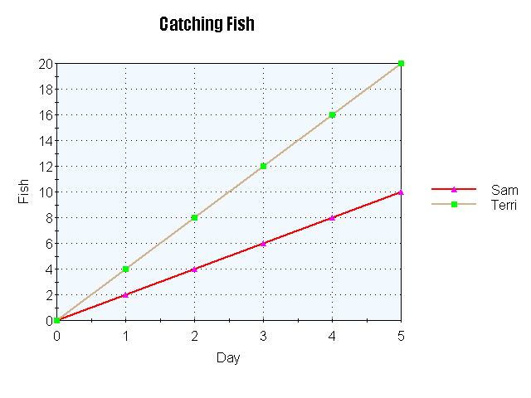

**Ideas for Home Support**

Maps are a great way to connect coordinate grids to everyday life. With your child, design a map of your neighborhood using graph paper by creating a coordinate grid and plotting important locations and recording their coordinates. Talk about available coordinates where new homes, buildings, or parks could be built. Create step-by-step directions for traveling from one location to the next (ex: “The clubhouse is 2 units to the right and 4 units up from the Johnson’s house.”)

**Thank you for serving as partners in your child’s success as a mathematician!**

**<signature>**